**Sophie™: A Patent Dispute Assessment and Resolution System[1]**

## The Problem: Relying on a Patent is a Gamble

The State University has asked Brad’s patent brokerage and licensing firm to help sell or license the rights to a portfolio of telecommunications patents. Brad is confident that the patents have commercial value if they are valid. Although Brad has extensive experience in telecommunications, knows some potential licensees, believes the patent claims are well written, and has found no disqualifying prior art, he’s not sure the patents are valid. Ultimately, taking on this portfolio —indeed, *any* portfolio—is a gamble.

Why is that so?

Whether a patent holder really owns a patent—the right to exclude others from using an invention—depends, ultimately, on what a court decides if the patent is challenged.[2] Frequently, however, what a court will do is anyone’s guess. For example, since the American Invents Act went into effect in 2012, the Patent Trial and Appeal Board (PTAB) has invalidated at least 58 patents that a federal court had already enforced.[3] No doubt, both sides in these cases believed they were right—and at least one judge or set of judges agreed with them.

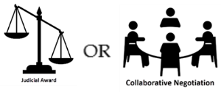Because well-informed, competent experts can reach different conclusions about whether one or more claims in a patent are patentable, patent holders and challengers must either take their chances with the judicial system or negotiate a voluntary settlement of their dispute. Many choose to settle.

According to statistics published by the US Patent and Trademark Office, from 2012 through March 2017, the parties settled 41% of all Inter Partes Review petitions not denied outright.[4]

Did the parties get the best outcomes possible or did they let value get away?[5] Unfortunately, research on non-patent cases shows that parties often make poor choices when crafting settlement agreements.[6]

Why does that happen?

*Uncertainty, complexity*, and *ambiguity* make settlement decisions difficult. Cognitive biases impede rational thinking. One stakeholder’s failure to consider the dispute from another stakeholder’s perspective—a perspective with which a judge or jury might well agree—compounds the problem.

Patent owners, investors, and patent challengers need no longer gamble, bluff, or rely on luck. With the advent of artificial intelligence, data analysis, and LRM’s proprietary algorithms, they can make well informed choices instead.

## Introducing Sophie™: A Patent Dispute Assessment and Resolution System

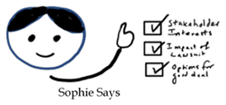Sophie™ will help stakeholders in patent disputes make a wise choice between the litigation path and a negotiated settlement by:

* identifying the full set of interests of all stakeholders, which is essential to crafting settlement strategies that leave little or no value on the table.
* assessing the probable impact of a lawsuit on those interests.
* organizing and assessing options for agreement that satisfy their interests better than a lawsuit.

Sophie™ will also help users manage the complex issues, facts, and relationships in a dispute, better understand how an opponent sees the matter (and how a neutral third-party *might* see it), and mitigate cognitive biases.

Sophie’s unique **multi-view analysis** will present each party’s likely perspective on a lawsuit, thereby helping all users

* achieve a more precise and deeper understanding of each stakeholder’s interests,
* assess the legitimacy and persuasive power of perspectives other than their own, and
* better appreciate the strengths and weaknesses of their own perspectives.

 Sophie™ will interact with users through a dashboard that gives users access to information, reports, and transparent decision-making audits.

Ultimately, Sophie™ will help all parties to patent disputes, save and make money—lots of money.

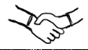

## The Main Components

### Interest Analysis

Understanding what matters most to which stakeholders and who has the most influence over settlement decisions is a necessary part of the negotiation process. Using LRM-proprietary algorithms and formulas as well as publicly available information, Sophie™ will help users achieve this understanding by using the interest-based method of negotiation, first developed at the Harvard Negotiation Project, to identify, organize, and prioritize the interests of individuals and organizations.

As part of this interest analysis, Sophie™ will identify the emotional components of a patent dispute.

Why is this important?

While consulting in a high-stakes patent enforcement case, Roger Fisher, founder of the Harvard Negotiation Project, used the role reversal technique to help the CEO of the defendant see the conflict from the perspective of the inventor plaintiff. At one point in the exercise, Fisher asked what it would take to settle this case. The CEO, playing the role of the inventor, responded, “I wouldn’t settle with you if you gave me your whole $&*#@ company.” The defendant reacted defensively, refused Roger’s advice, and eventually lost. The plaintiff *did* get the whole company.

The resolution of disputes *always* involves both rational and emotional components. If we focus solely on the rational components, we will miss much of the information needed to craft an optimal outcome.

### Patent Claims and Lawsuit Analysis

Predicting the probable impact of a patent dispute on the interests of stakeholders requires the organization and management of large amounts of information specific to the dispute at hand in the context of court decisions in similar cases. Patent litigation specialists do this work. Sophie™ will help them manage complexity, reduce uncertainty, avoid the pitfalls of cognitive biases, and, perhaps most important, see the case as others see it.

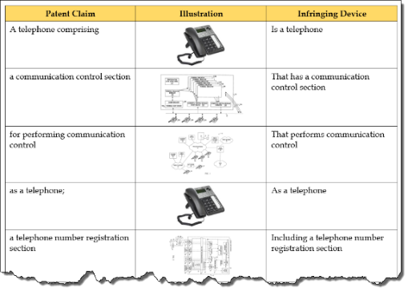Patentability is the threshold issue in patent disputes. Accordingly, Sophie™ will incorporate a robust claims analysis that will assist users in comparing the claims of the patent with the features of the device alleged to infringe those claims. Using Natural Language Processing technology and other resources, Sophie™ will analyze the individual claims and the properties of the allegedly infringing device. It will then generate an estimate of the probability that a court will find the claims patentable and that the device infringes those claims.

The patentability analysis will help users predict whether a court or the PTAB will invalidate one or more claims in response to an IPR petition. Apart from its obvious value in the litigation context, this feature will also be useful in helping practitioners like Brad (remember Brad?) decide whether to acquire patent rights and negotiate license agreements.

Sophie™ will use formulas to produce a side-by-side analysis of each party’s case and its estimated financial value and risk.

The basic formula is not complicated: To get the present value of a lawsuit for the plaintiff, multiply the likelihood of a liability finding for the plaintiff times the estimated average damage award, subtract the remaining costs, and discount the future value to the present. To calculate the risk to the defendant, multiply liability times damages and add the remaining costs. The extended formula involves calculations for prejudgment interest, post-judgment interest, potential fee shifting, and many other factors.

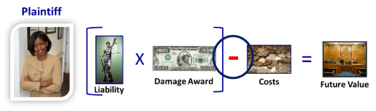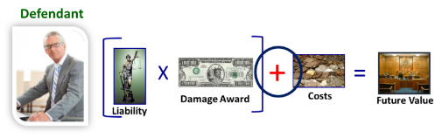

Sophie™ will

* collect the available evidence from the user,
* 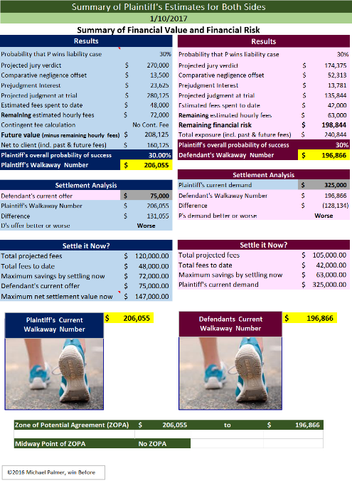gather the parties’ respective stories,
* analyze each side’s story for logical consistency, legal claims and defenses, and emotional content,
* assess the strengths and weakness as well as the overall persuasiveness of each side’s case,
* assess the knowledge and skills of the judge and advocates,
* assess the likely impact of extrajudicial factors on the ultimate decision,
* estimate the probability of success on liability in court for each side’s case,
* estimate the amount of damages that could be awarded if plaintiff prevails,
* estimate the costs each side will incur if the case is litigated to a final judgment, and
* produce a side-by-side comparison of the financial value/risk of plaintiff’s and defendant’s cases.

An undertaking of this size and complexity is possible only because artificial intelligence tools and other resources can be incorporated into Sophie. In addition to information obtained directly from the user (e.g., evidence and stories), Sophie™ will integrate publicly available databases and tools from third-party partners such as Digitory Legal, Lex Machina, GreyB, and Lex Predict.

### Option Management

Each party to a dispute usually has a wish list for a settlement agreement, commonly expressed as demands or a position. Often, the result of this approach is a positional haggle in which each side makes grudging concessions from an extreme opening position (generally, how much money the defendant will pay the plaintiff to go away). Positional bargaining of this sort is a major reason why parties achieve sub-optimal settlement agreements, let real value fly away as they shake hands.

To improve on such outcomes, the parties should explore a variety of options that satisfy their respective interests as well or better than the likely net result of a lawsuit. If they do this well, each can often give the other something of value, at little or no cost to themselves, that no court could order (information, for example).

Through a unique exploratory system, Sophie™ will help parties avoid or overcome positional bargaining by

* stimulating the discovery of options for agreement that address various stakeholder interests,
* estimating the extent to which those options satisfy the respective interests,
* recording and keeping track of the options/interest analysis, and
* estimating the overall value of a package of options for each stakeholder compared with the probable net result of the litigation alternative.

## Users and Applications

Sophie™ will address the needs of

|  |  |
| --- | --- |
| * patent brokers | * IP departments |
| * non-practicing entities | * in-house counsel |
| * patent licensing firms | * patent consulting firms |
| * patent litigation attorneys | * patent financing firms |
| * judges and law clerks | * patent dispute mediators |

Sophie™ will help Brad, the patent broker mentioned at the outset, estimate the probability that the patents in the university’s telecommunications portfolio will withstand a challenge in court or the PTAB, an estimate he can use to negotiate a better license deal with a telecommunications company.

For everyone who works with and relies on patents, Sophie™ will confer an extraordinary advantage.

## Summary of Key Benefits

* Patentability Analysis
* Rational and transparent prediction of probable litigation outcomes
* Analysis of the interests of all important stakeholders in a given dispute, including the relative priorities among the interests and the comparative importance to each stakeholder of the settlement options under consideration.
* Multi-view prediction techniques that help all stakeholders understand the probable impact of a lawsuit on their interests and those of other stakeholders compared with the impact of options for a proposed settlement.
* Quantification of legal fees and damage awards, opportunity costs, diverted employee time, emotional turmoil, stakeholder trust, and reputation (brand).

Like the sailor’s sextant or the hiker’s compass, Sophie™ will be a tool that helps those involved in a legal dispute navigate the settlement process. It will change the basis for decisions from an uninformed gamble to a prudent judgment.

Contact:

Mike Palmer, 802 398 7737; [mike@lrm.ai](mailto:mike@lrm.ai)

Charles Barker, 847 644 2494; [cb@primemover.co](mailto:cb@primemover.co)

1. © 2018 Legal Risk Management, Inc.; contact Mike Palmer, 802 870 3450; [mike@lrm.ai](mailto:mike@lrm.ai).
2. *See* Louis Carbonneau, “[What makes a patent valuable; A patent broker’s perspective](https://www.ipwatchdog.com/2015/02/03/what-makes-a-patent-valuable-a-patent-brokers-perspective/id=54441/),” IPWatchdog (Feb. 3, 2015) (“[P]atents are nothing else than ‘litigious rights’ reflected in a government issued title which can be passed to others via a sale, or partitioned out via licenses.”).
3. *See* Steve Brachman and Gene Quinn, “[58 Patents Upheld in District Court Invalidated by PTAB on Same Grounds](http://www.ipwatchdog.com/2018/01/08/58-patents-upheld-district-court-invalidated-ptab/id=91902/),” IPWatchdog (Jan. 28, 2018). Inconsistent judgments of this kind are commonplace in the American judicial system. Appellate courts reverse trial courts only to be reversed by even higher courts, with 5 justices laying out a cogent argument supporting the winning view and 4 justices stating an equally compelling rationale for the opposite conclusion. *See also* Bloomberg BNA, *Patent Litigation Strategies Handbook*, 4th Edition, Chapter 4 (“The number of cases in which district courts have incorrectly construed at least one claim term following the Supreme Court's Markman decision has approached a staggering 40 percent.”).
4. *See* [Patent Trial and Appeal Board Statistics](https://www.uspto.gov/sites/default/files/documents/AIA%20Statistics_March2017.pdf) 10 (March 31, 2017). Almost half (47%) of the 4563 IPR petitions filed from September 2012 through March 2017 were either denied outright (1,317), settled (759), or otherwise terminated. Of the remaining 2,406 cases (53%), 829 were terminated by settlement, dismissal, or with a request for adverse judgment. Only 1,577 (34.5% of all petitions) were tried to judgment, with the challenger prevailing on some or all claims 81% of the time and the patent claims being fully upheld in the remaining 19% of cases.
5. Such deals are called [Pareto-optimal Agreements](https://en.wikipedia.org/wiki/Pareto_efficiency). By working together, parties can help each other obtain maximum value without thereby diminishing the value they receive.
6. *See* Randall Kiser, *Beyond Right and Wrong: The Power of Effective Decision Making for Attorneys and Clients* 29-85 (New York: Springer 2010); Jane Goodman-Delahunty, Pär Anders Granhag, Maria Hartwig, and Elizabeth Loftus, “Insightful or Wishful: Lawyers’ Ability to Predict Case Outcomes,” 16(2) Psychology, Public Policy, and Law 133 (2010); Marijke Malsch, Lawyers‘ Predictions of Judicial Decisions (doctoral thesis, University of Leiden, The Netherlands, 1989); Elizabeth Loftus and Willem A. Wagenaar, “Lawyers’ Predictions of Success,” 28 Jurimetrics Journal 437 (1988).